Min-max theorem

Def

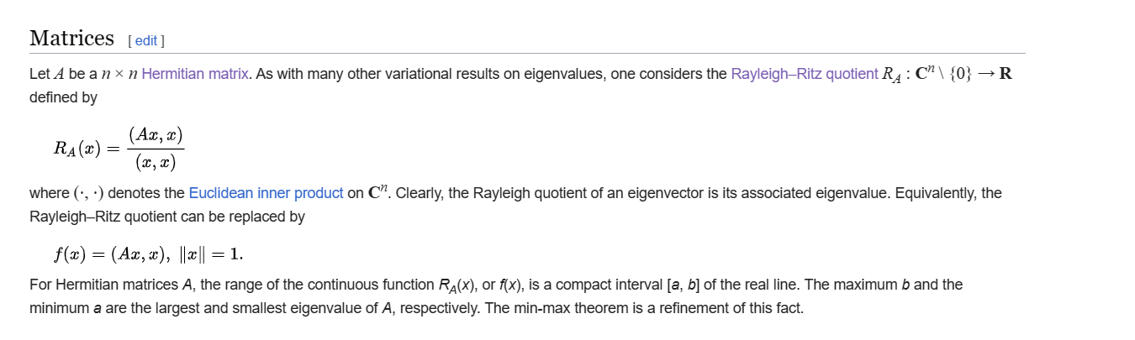

Property

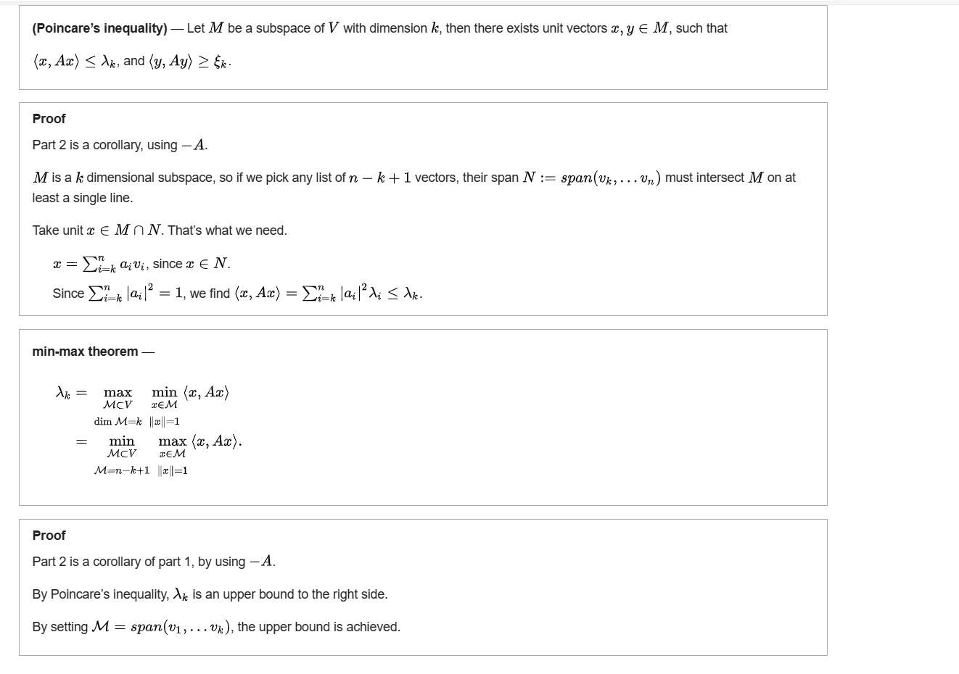

Ref

[Min-max theorem - Wikipedia](https://en.wikipedia.org/wiki/Min-max_theorem)